IT24103407

PS Lab 7

1..

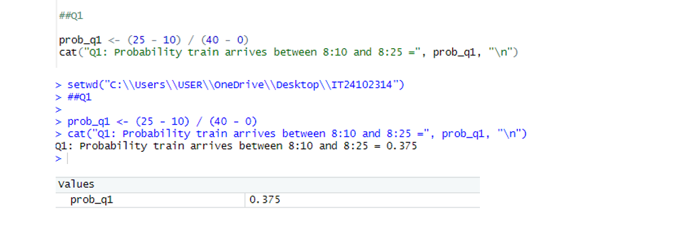

2..

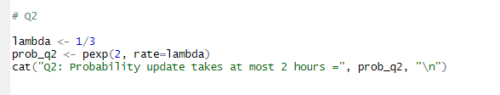

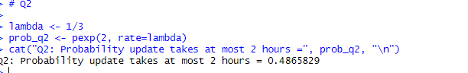

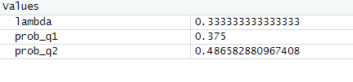

3..

